Ideation Phase
Define the Problem Statements

Date | 26 September 2026
Team ID | SWTID-2026-9376
Project Name | FitTrack AI – Personalized Fitness Recommendations Powered by AI
Maximum Marks | 2 Marks

Customer Problem Statements
FitTrack AI – Personalized Fitness Recommendations Powered by AI is developed for users who want to maintain workout records and receive personalized fitness guidance. The customer problem statement helps identify the major challenges faced by users while managing workout history, tracking exercise activities, finding suitable workout plans, and understanding fitness progress.
A well-defined customer problem statement helps in understanding the user’s needs, difficulties, and emotions. It also supports the development of a solution that addresses workout management problems and provides personalized recommendations based on the user’s fitness goals and experience level.
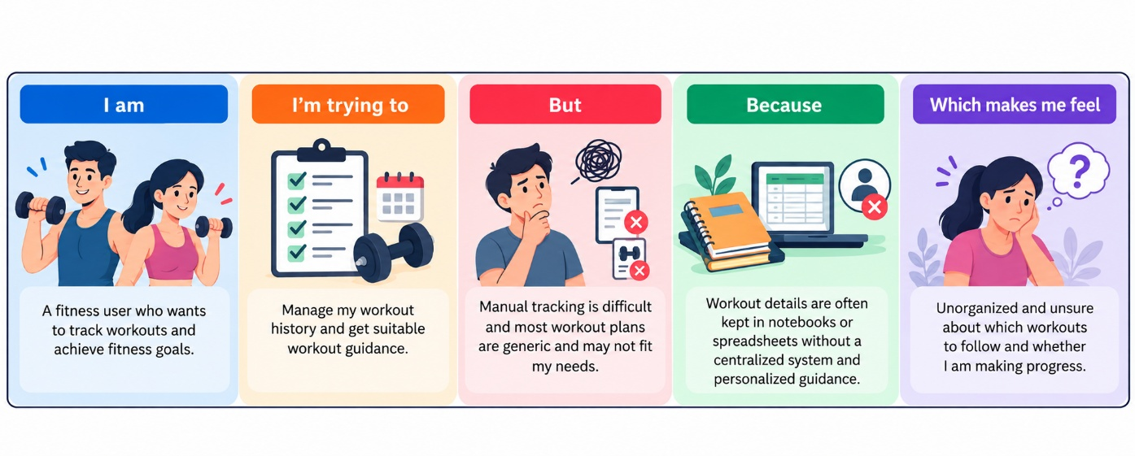
Problem Statement (PS) | I am (Customer) | I’m trying to | But | Because | Which makes me feel
PS-1 | A fitness user who wants organized workout records. | Track and review my workouts. | Manual tracking is difficult. | Records are stored in notebooks or spreadsheets. | Unorganized and frustrated.
PS-2 | A user who wants personalized workout guidance. | Find workouts that suit my goals. | Most workout plans are generic. | Personalized guidance is not easily available. | Unsure about what to follow.
PS-3 | A beginner who is new to fitness. | Start with suitable exercises. | Beginner guidance is hard to find. | Many plans are designed for experienced users. | Confused about how to start.
PS-4 | A user who wants to understand progress. | Review workout duration and calories burned. | Raw workout records are hard to analyze. | Manual tracking gives limited insights. | Unsure about my progress.

